Loan Approval using ML algorithms
ArpithaSingh(R22DG002) Nandini.v(R22DG03) MeruvaSivani(R22DG030) ValmikiSarath(R22DG061) MSc(DS)-II Semester

Abstract: Loan approval is a critical process in the financial industry, and the use of machine learning (ML) algorithms has shown promise in improving its accuracy and efficiency. This research paper investigates the application of three popular ML algorithms, namely Logistic Regression, Decision Tree, and Linear Regression including other algorithms GaussianNB, Random Forest, SVM for loan approval. The study utilizes a comprehensive dataset comprising historical loan applications, encompassing various features such as borrower demographics, credit scores, income levels, and employment histories. The major outcome of this research paper is to compare the performance of those algorithms and their metrices accuracy, precision, recall and F1-score. Additionally, the paper examines the interpretability and transparency of the ML models, enabling an understanding of the factors driving loan approval decisions. In conclusion, this research paper highlights the effectiveness of Logistic Regression, Decision Tree, and Linear Regression algorithms in loan approval. The findings demonstrate their superiority over traditional approaches and emphasize their potential to enhance the accuracy and efficiency of the loan approval process. Additionally, the interpretability techniques employed contribute to the transparency of the ML models, addressing concerns related to bias and regulatory requirements. By developing this model, we can improve the ML-based loan approval systems and it will also help for the financial industry, which makes them to improve decision-making and customer experience. The whole paper is divided into 7 sections.

- INTRODUCTION
Machine learning is a subfield of artificial intelligence (AI) that deals with the development of algorithms and statistical models that enable machines to learn from data and make predictions or decisions without being explicitly programmed.
Machine learning is a way of enabling computers to automatically improve their performance on a particular task by learning from experience or data. It also involves the use of algorithms and statistical models to analyze and make predictions or decisions based on patterns in the data.
Machine learning can be broadly categorized into three types: supervised learning, unsupervised learning, and reinforcement learning.
Supervised learning involves training a machine learning model using labelled data, while unsupervised learning involves training a model without labelled data. Reinforcement learning, on the other hand, involves training a model using a reward-based system, where the model learns by trial and error.
Machine learning has a wide range of applications, including image and speech recognition, natural language processing, recommendation systems, fraud detection, and autonomous vehicles, among others.
Data mining techniques are very useful in this field. Data mining is a process of extracting meaningful knowledge from a large and unstructured amount of data. Such extracted information can help in decision-making through performing important operations.
For the loan approval prediction, there are many traditional data mining methods. Machine-learning algorithms are available to automate the loan status prediction system. Which are used to predict the right person who deserves the loan, many machine learning algorithms, such as decision tree, gradient boosting,
random forest, logistic regression, and many more, can predict the right person who deserves the loan. Therefore, this paper aims at risk to approve the loan by predicting the loan status based on different loan factors or features.
Loan Prediction is very useful for banks as well as employees and applicants. The primary objective of this research paper is to provide a quick and easy way to make the best decision. In this the loan prediction system can automatically calculate the weight of each feature which leads to making the best decision. Here we can set the time to check the status of the customer to see that the customer is permits or not. In this the system jumps to specific application to check on priority basis. This research paper is particularly for the managing authority of Bank/finance company. This whole process is done privately and none of the stakeholders would be able to change the process. The results are sent to the various departments of banks then the applicants taken a part and the actions will be taken. This is very useful and helps all other departments to carry out other gestures.
- LITERATURE REVIEW
By using the data, we need to build the model that will help to predict the to give the loan to that person depending on his information like gender, married or not, dependent or not, graduation, self-employed, applicant income, Co-applicant income, amount. There are so many models which can predict the loan approvals.
S M Fati studied at Prince Sultan University as Computer and Information Sciences. He did Machine Learning-Based Prediction Model for Loan Approval by Appling the three machine learning algorithms Logistic regression, Decision Tree, and Random Forest.
The process he did was firstly the data source he collected then done some dataset Description and Pre-processing. Decided which model is suitable for this data source. Then he applied the machine learning algorithm.
The prediction for loan approval using machine learning algorithm is written by Ashwini S, Shraddha R, Ankita A, Gayatri V, Amar S. Here they used Navie Bayes (NB) Model and SV method. They approach this by firstly EDA and the machine learning steps data collection, data cleaning and pre-processing, model selection, data verification, classification and report deliver.
Loan approval prediction based on machine learning is written by Kumar Arun, Garg Ishan and Kuar Sanmeet studied at Thapar University, India. They used Decision Tree, Random Forest, SVM, Linear regression form linear models , GaussionNB and Logistic Regresson.
Mohammad Ahmad Sheikh he is the student at Galgotias University Greater Noida, India. He and another two professors from the same university and the department of school of computer science and engineering written a paper “An Approach for Prediction of Loan Approval using Machine Learning Algorithm”. They came with the problem statement.

The below page need to be done.
Loan prediction is a very common real-life problem that every finance company faces in their lending operations. If the loan

approval process is automated, it can save a lot of man hours and improve the speed of service to the customers. The increase in customer satisfaction and savings in operational costs are significant.
However, the benefits can only be reaped if the bank has a robust model to accurately predict which customer's loan it should approve and which to reject, in order to minimize the risk of loan default.
They did a neat approach to this problem statement they used the logistic regression model for this analysis. They did some model evaluation techniques like Confusion metrics, Accuracy, Precision, Recall and F1 score. These are the techniques which help to evaluate the performance of the model.
Some of the faculties of engineering and computer sciences, iNurture, TMU, Moradabad and another from Department of Computer Science, Government Engineering College, Bharatpur. The name of the faculties is Anshika Gupta, Vinay Pant, Sudhanshu Kumar and Pravesh Kumar Bansal written a paper on the Bank Loan Prediction System using Machine Learning. In this first they prepared the methodology regarding that they used logistic regression and random forest machine learning algorithms for the loan prediction.
Tree-Based Methods for Loan Approval written by Mohamed Alaradi pursuing MSc. in Big Data Science and Analytics University of Bahrain. He applied some techniques like Decision tree, Bagging, Random Forest, Boosting, Performance Metrics, programming software. By applying they got to know about the accuracy of each method which will help in the Loan Approval process.
Loan Prediction is very helpful for employee of banks as well as for the applicant also. The aim of this Paper is to provide quick, immediate and easy way to choose the deserving applicants. It can provide special advantages to the bank. The Loan Prediction System can automatically calculate the weight of each features taking part in loan processing and on new test data same features are processed with respect to their associated weight.
There are numerous fields where data mining can be used in financial industries such as customer segmentation and profitability, applicants for high-risk loans, predicting default payments, promotions, collateral monitoring, rating assets, irregular sales, managing stock holdings, cash management and estimating activities, most profitable clients with credit cards and cross-selling. One of the common tools used today in data mining is Weka. The Weka facilitates these traditional data mining functions in the pre- processing, classification, clustering, association, regression and feature selection phases. It also provides a visualization tool. And it is useful in learning basic machine learning principles with various
options and in analyzing the output being generated.
The current work aims at automating the process of loan approval by using statistical learning methods based on a bank’s historical data that outlines certain characteristics of the applicants. The rationale behind this work is obviously minimizing risk and enabling bank personnel to take better decision and judgment on selecting eligible candidate for loan approval.
Predicting a modernized loan approval system is incredibly helpful for banks and also the clients. This system checks the candidate on his priority basis. A customer can submit his application directly to the bank so the bank will do the whole process, no third party or stockholder will interfere in it. And finally, the bank will decide that the candidate is deserving or not on its priority basis. The only object of this research paper is that the deserving candidate gets straight forward and quick results.
Three Machine Learning algorithms which are used to find out the correct prediction of Data set Logistic Regression, Linear Regression, GaussionNB, Random Forest, decision tree and SVM.

P. L. Srinivasa Murthy1, G. Soma Shekar2, P. Rohith3, G. Vishnu Vardhan Reddy4 written the paper on Loan Approval Prediction System Using Machine Learning. The system is highly effective for
identifying eligible loan applicants and can cater to all banking needs. It can seamlessly integrate into any operating system and has a promising future with the shift towards online platforms. The system ensures strong security and reliability, Here the author used three algorithms for prediction of loan. They are 1.) K Nearest Neighbor 2.) Decision Tree 3.) Random Forest Algorithm, which provides precise outcomes. It can handle a large number of customers without any complications, and there is potential for enhancing accuracy by incorporating additional algorithms in the future.
Kshitiz Gautam, Arun Pratap Singh, Keshav Tyagi, Mr. Suresh Kumar in Loan Prediction using Decision tree and Random Forest used training data set to train our model. After the model is trained, we test it with unknown examples from the same scenario. Another process that we use before testing and training data is data pre- processing. In data pre-processing we remove all sorts of values that can cause an error like redundant values, incomplete values, missing data, etc.
An Approach for Prediction of Loan Approval Using Machine Learning Algorithm written by Ms. Kathe Rutika Pramod1, SVIT, Nashik2, Ms. Dapse Punam Laxman3, Ms. Panhale Sakshi Dattatray4, Mr. Ghorpade Dinesh B.5, Ms. Avhad Pooja Prakash6. The analytical process included data cleaning, missing value imputation, exploratory analysis, and model building with an accuracy of 0.811 on the public test set. It revealed that applicants without a passing credit history are often rejected due to a higher probability of defaulting. Additionally, applicants with higher incomes but lower loan amounts are more likely to be approved as they are perceived as reliable borrowers. Surprisingly, basic characteristics such as gender and marital status do not significantly influence the company's approval decisions.
Loan Approval Prediction using Machine Learning Algorithms Approach written by Nitesh Pandey1, Ramanand Gupta2, Sagar Uniyal3, Vishal Kumar4. Here the author used three algorithms for prediction of loan. They are 1.) Support Vector Machine (SVM) 2.) Decision Tree 3.) Random Forest Algorithm 4.) Logistic Regression
5) Linear Regression 6) GaussionNB. This paper focused on using machine learning for loan acceptance prediction. The process involved data pre-processing, handling missing values, and conducting experimental data analysis. The precision rates of the evaluated algorithms ranged from 70% to 80%. Notably, the Support Vector Machine model demonstrated high efficiency and outperformed other models, making it the preferred choice for loan acceptance prediction.
In Somayyeh. Z et al[1] a model was proposed for predicting and identifying the right applicants who have applied for loan. So here Decision Tree technique is implemented to estimate the traits where accuracy rate is not much appreciable.
In Sudhamathy G et al ., This paper aims to build a model. It was based on decision tree where classification is used. It also uses the functions in the R-Package. Before preparing the model, the data is synchronized, made it ready to deliver effective results. The model prepared is used for predict using the dataset and the results shows the accuracy. In Dileep. B et al, Data analysis was done by figuring out techniques like Bayes classification, Decision Tree, Logistic Regression, K means algorithm, Neural Network Techniques, Perception model are combined in this model.

Table 1: The following is the Summary of the existing works on the given domain:

Year | Previous Works | Tool used | Techniques used | Advantages | Disadvantages
2021 | [1] | Python | Logistic Regression Box plot |  | --------
2021 | [2] | R | Decision Tree (C5.0), Random Forest, Support Vector Machine (SVM), linear Model, Neural Network (Nnet), Adaboost (ADB). | The product is a highly efficient component. This application works properly and meets all Banker requirements. This component can be easily plugged into many other systems. | computer glitches, errors in content and most important weight of features are fixed in automated prediction system, So in the near future the so – called software could be made more secure, reliable and dynamic weight  adjustment.
2020 | [3] | R | Decision tree, Random Forest | This application operates efficiently and fulfilling all the major requirements of Banker. Although the application is flexible with various systems  and can be plugged effectively. | Numbers of cases of computer glitches, errors in content and most important weight of features are fixed in automated prediction system
2021 | [4] | Python | XGBoost, Random Forest, Decision Tree | The advantage of this system is that we provided some conditions by setting the algorithms and just by evaluating the details, we get to know eligibility criteria that client is eligible or not. | some situations like client going through some disaster so here the algorithm cannot predict the appropriate result.
2020 | [5]. | Python | Decision Tree Bagging Random Forest Boosting | In this work, many statistical learning classification techniques were performed under the pursuit of predicting loan approval status for a bank | Numbers of cases of computer glitches, errors in content.
2021 | [6] | Weka | Decision Tree Logistic Regression | The output is in the form of 0 and 1(binary form), were ‘1’ indicates that loan is approved and ‘0’ for loan rejected. | some situations like client going through some disaster so here the algorithm cannot predict the appropriate result.
2020 | [7] | Python | Confusion Metrics, Accuracy, Precision, Recall, F1 Score | Among all the techniques, the best- case accuracy obtained on the original data set is 0.811. | Some other characteristics like gender and marital status seems not to be taken into consideration by the company
2021 | [8] | Python | Naïve Bayes (NB) Model and Support Vector Machine (SVM) | Naïve Bayes model is extremely efficient and gives a better result when compared to other models. It works correctly and fulfills all requirements of bankers. | Support Vector machine (SVM) won’t give that much accuracy and efficient result.
2016 | [9] | R | Decision Tree (C5.0), Random Forest (RF), Support Vector Machine (SVM), Linear Models (LM), Neural Network  (Nnet), Adaboost (ADB) | It can be safely concluded that the product is a highly efficient component. | There have been numbers of cases of computer glitches, errors in content and most important weight of features  is fixed in automated prediction system
2020 | [10] | Python | Logistic Regression, Random Forest, Correlation betweenParameters | This model is used for the banking system or anyone who wants to apply for a loan. It willbe very helpful in bank management. It reduces all the  frauds done at the time of loan approval. | As it seems, it will not deal with some special cases when only one parameter is enough for the decision,but it is quite efficient and reliable insome instant.

- DATASET DESCRIPTION
For all the machine learning models we need to build model by using the dataset divide them into train and test data. We need to train the model by using train data and then applying the model on the test data.
In this Dataset we have 12 columns and 614 customer records. All these records are in the csv format. We can use pandas library for reading the file and by using python we can apply all the algorithms. In that dataset Status is the target variable and the other variables- “Gender”, “Married”, “Dependents”, “Education”, “Self-Employed”, “Applicant Income”, “Co-applicant Income”, “Loan Amount”, “Term”, “Credit History”, “Area”.
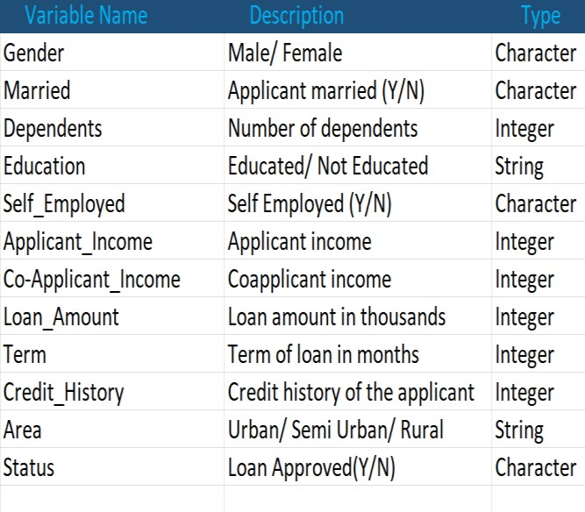

Table-2: Data Set variables with description and type

From the above image we can know the features of the variables which are present in the data set. The next step is to handle the null values. This is done by different methods, but we have enough data, so we are removing the null values. All the records of the applicants are in the form of categorical and numerical data. The dataset has missing values and null values. Before the analysis we need to normalize the dataset by removing the null values.
- METHODOLOGY
Loan approval prediction methodology is a way to predict whether a loan application will be approved based on historical data and statistical techniques. The algorithms that we are going to use in the paper is Logistic Regression, Linear Regression, Decision Tree, SVM, Random Forest and GaussionNB. All these algorithms are trained on historical data to learn the relationships between the different factors that affect loan approval. The loan approval prediction methodology can be a valuable tool for banks. It can help banks to make more informed decisions about loan applications and to reduce the risk of loan defaults.

Here are the steps for approach.

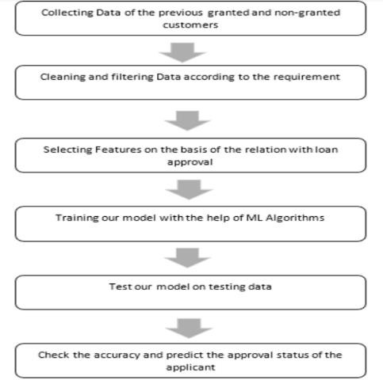
Fig 1: Steps
- Logistic Regression: Logistic regression is one of the most popular machine learning algorithms, which comes under the supervised learning technique. It is used for predicting the categorical dependent variable using a given set of independent variables. The outcome must be of a categorical or discrete value. It can be either Yes or No, 0 or 1, true or false, etc.
- Decision Tree: Decision tree is a supervised learning technique that can be used for both classification and regression problems, but mostly it is preferred for classification problems.
- Linear Regression: Is one of the most popular machine learning algorithms. It is a statistical method that is used for predictive analysis. This algorithm shows a linear relationship between a dependent (y) and one or more independent (y) variables.
- Random Forest: Random Forest is a machine learning algorithm that belongs to the supervised learning technique. It can be used for both classification and regression problems in ML.
- Navie Bayes model GaussionNB: This is a Navie Bayes model. In this model the events are mutually exclusive. It also comes under the supervised machine learning algorithm.
- Support Vector Machine (SVM): The SVM algorithm is one of the most powerful supervised learning algorithms, which is used for both classification and regression problems. But mostly used for classification problems in ML.

- DATA PREPROCESSING
Before removing the null values, the value count of every variable that present in the data set is:
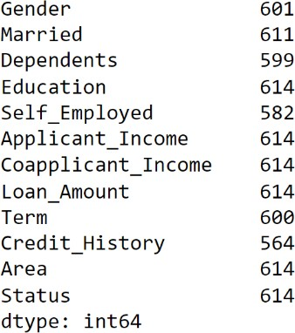

Fig 2: With null values

We can’t handle imbalance data and we can’t apply machine learning algorithms also to the imbalance records, so we need to normalize this data by removing the null values.

After removing the null values, the value count of every variable is:
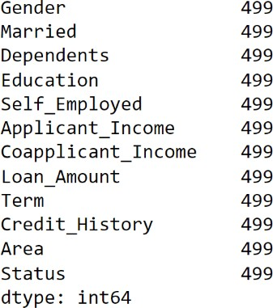

Fig 3: without null values
Normalizing the dataset is done. Now the dataset is further divided into training and testing. By using the train data, we need to train the model and test the model by using the test data.

Here we use describe () function which gives the parameters like count, mean, max, min, and the quartiles etc.

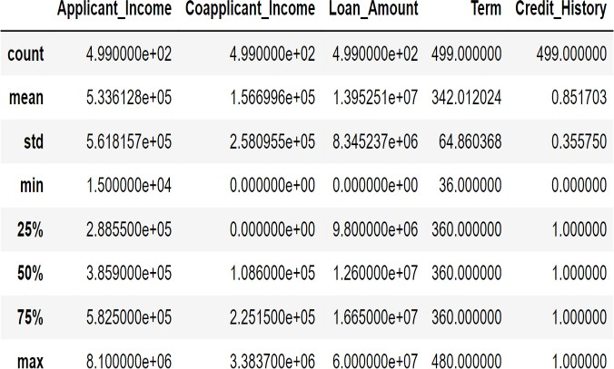

Fig 4: description of dataset

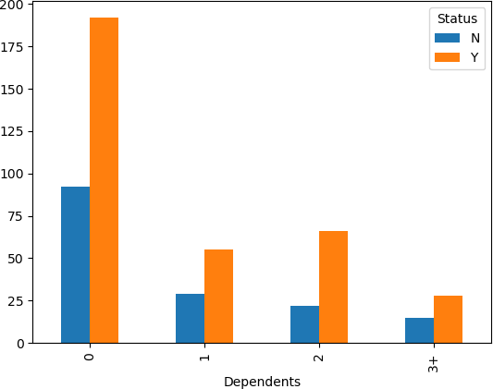
NEED TO ADD ABOUT THE CHART
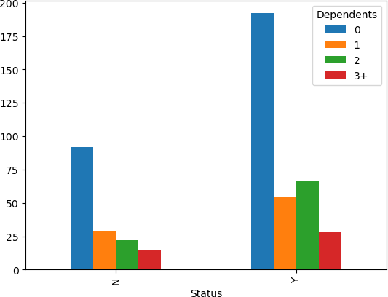

Fig 5: Relation Between Dependent and Education
Here we see that Dependents who are graduated have more chances of approval of their loans.

As we observed the figure 4, if anyone is married, he/she would be more likely to have a loan.

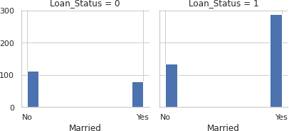

Fig 6: Relation between Married and loan status

Table 2:

 | Married | Loan_Status
0 | No | 0.629108
1 | Yes | 0.718204

From the above table, if a female is married and not graduated, she would be more likely to approved for the loan. If any female is not married, she still would be more likely to have approved for the loan than a male.

The last step before applying the model is to know the relations between the variables. For that we need use the corr() method that will shows us all the correlations between all the variables.
The below figure shows the heat map correlations between all the variables present in the data set. So that we can easily do further analysis.

II. Accuracy

Accuracy means the number of correct predictions by total number of predictions. The accuracy is high for the balanced class model and for the unbalanced class model the accuracy is very less.

By classification table

(𝑇𝑃 + 𝑇𝑁)
(𝑇𝑃 + 𝐹𝑃 + 𝑇𝑁 + 𝐹𝑁 )

III. Precision:
Precision is one of the classification metrics in machine learning. It refers to the number of true positives divided by total number of positive predictions.

IV. Recall:

Recall and precision are two extremely important model evaluation metrics. Recall refers to the percentage of total relevant results correctly classified by your algorithm.

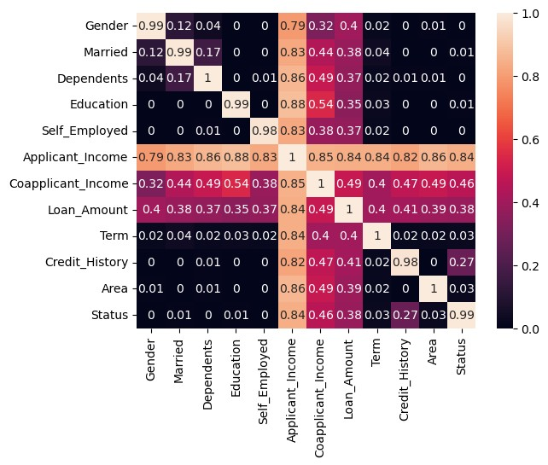
Fig 7: Representing the correlation between attributes using the

V. F1 Score:

TP
𝑇𝑃+𝐹𝑁

heatmap
- MODEL EVALUATION
Model evaluation is a technique used to evaluate the model performance based on some limitations. We need to consider Accuracy, precision, recall, F1 score to evaluate the model performance. For all the metrics we need to build the confusion metrics.

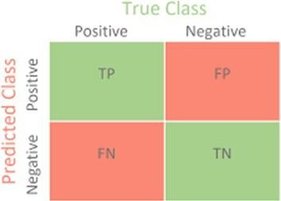
- Confusion Matrix
F1 Score is a machine learning evaluation metric that measures a model’s accuracy. The F1 score combines the precision and recall scores of a model.

- RESULTS AND ANALYSIS

Here we got the accuracies of the models Logistic Regression, Decision Tree, Random Forest, GaussionNB, SVM.

Algorithms | Accuracy
Logistic Regression | 80%
Decision tree | 69%
Random Forest  GaussianNB SVM | 78%  78%  77%

These are the linear regression model metrics results:

MSE | 0.154
RMSE | 0.392
Train Set Score Test Set Score | 0.27  0.32

The Mean Squared Error measures the average squared difference between the predicted values and the actual values. As we observed the MSE value is 0.1543 which is relatively low. The Root Mean Squared Error is the square root of the MSE value and this will provides a more interpretable metric. The value of the RMSE is 0.3928.

The training set score and the test set score represent the model’s performance on the train and test datasets. These score range from 0 to 1, with higher values indicating the best performance. Form the above results the scores for the train and test is relatively low training set score 0.27 and the testing set score 0.32.

By analyzing all the results of the linear regression metrics that is concluded that linear regression may not be the best fit for this approval project.
Comparing the accuracies of the machine learning algorithms the logistic regression performed the best with an accuracy of 80%. It is better than other models such as decision tree(69%), random forest (78%), GaussionNB(78%), SVM(77%) and the linear regression is having the lowest metrics values MSE, RMSE and scores. The logistic regression model achived the highest level of correctness in predicting loan approvals.

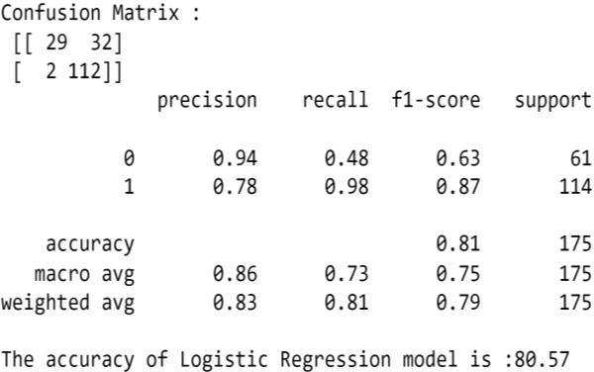
Confusion matrix of the logistic regression model

Here are the results of the evaluation metrics which show that the logistic regression performance is high.
- CONCLUSION(NOT DONE)
In the loan approval project, several machine learning models were evaluated, and logistic regression emerged as the most accurate model with an accuracy of 80%. This means that the logistic regression model achieved the highest level of correctness in predicting loan approvals compared to other models like Decision tree, random forest, GaussianNB, Logistic Regression, Linear Regression and SVM.

There are several reasons why the logistic regression model has achieved higher accuracy. Originally, logistic regression is a fixed and widely used algorithm for binary classification problems. It is specifically designed to estimate the probability of an event occurring, making it a suitable choice for determining the probability of approving or rejecting. Then, logistic regression is generally less prone to overfitting, compared to more complex models like decision trees and random forests. Overfitting occurs when a model learns the training data too well, resulting in poor generalization to new, unseen data. Logistic regression is efficient and somewhat understandable compared to other models like support vector machines (SVM) or random forests. If the relationship between the input variables and the loan approval decision is relatively linear, logistic regression can effectively capture this pattern and make accurate predictions.

In conclusion, the loan approval project found that logistic regression outperformed other models, achieving the highest accuracy with 80%.
From the proper view of analysis this system can be used perfectly for detection of clients who are eligible for approval of loan. This paperwork can be extended to a higher level in future so the software could have some better changes to make it more reliable, secure, and accurate. Thus, the system is trained with a present data set which may be older in future so it can also take part in new testing to be made such as passing new test cases.

- REFERENCES
- Suliman Mohamed Fati; Machine Learning-Based Prediction Model for Loan Status Approval 2021 College of Computer and Information Sciences, Prince Sultan University, Riyadh, Saudi Arabia.
- Ashwini S. Kadam1, Shraddha R. Nikam2, Ankita A. Aher3, Gayatri V. Shelke4, Amar S. Chandgude 5; Prediction for Loan Approval using Machine Learning Algorithm 2021; Student, Dept. Of Computer engg., SND College of Engineering and research centre, Yeola, Maharashtra, India 5Professor, Dept. Of Computer engg., SND College of Engineering and research centre, Yeola, Maharashtra, India.
- Kumar Arun, Garg Ishan, Kaur Sanmeet; Loan Approval Prediction based on Machine Learning Approach 2016; CSED, Thapar University, India.
- Mohammad Ahmad Sheikh School of Computing Science & Engineering Galgotias University Greater Noida, India, Amit Kumar Goel Professor and Tapas Kumar, An Approach for Prediction of Loan Approval using Machine Learning Algorithm 2020; School of Computing Science & Engineering Galgotias University Greater Noida, India.
- Anshika Gupta1, Vinay Pant2, S2, anshu Kumar3 and Pravesh Kumar Bansal4 Bank Loan Prediction System using Machine Learning 2020; Faculty of Engineering and Computing Sciences, iNurture, TMU, Moradabad 4 Department of Computer Science, Government Engineering College, Bharatpur.
- Mohamed Alaradi MSc. in Big Data Science and Analytics Tree- Based Methods for Loan Approval 2020; University of Bahrain and Sawsan Hilal College of Science University of Bahrain.
- Kumar Arun et al., 2021 proposed Loan Approval Prediction based on Machine Learning Approach, OSR Journal of Computer Engineering (IOSR-JCE).

- Ramachandra H V et al., 2021 proposed Design and Simulation of Loan Approval Prediction Model using AWS Platform, International Conference on Emerging Smart Computing and
Informatics (ESCI). .
- Mohamed Alaradi MSc. in Big Data Science and Analytics, 2020
authored Tree-Based Methods for Loan Approval, International Conference on Data Analytics for Business and Industry: Way Towards a Sustainable Economy (ICDABI).
- Vishal Singh et al., 2021, Prediction of Modernized Loan Approval System Based on Machine Learning Approach, International Conference on Intelligent Technologies (CONIT).
- Loan Approval Prediction System Using Machine Learning; P. L. Srinivasa Murthy, G. Soma Shekar, P. Rohith, G. Vishnu Vardhan Reddy. Associate Professor and Head, Department of Computer Science and Engineering, Institute of Aeronautical Engineering, Hyderabad, India. 2, 3, 4 Department of Computer Science and Engineering, Institute of Aeronautical Engineering, Hyderabad, India.
- Ms. Kathe Rutika Pramod1, Ms. Dapse Punam Laxman2, Ms. Panhale Sakshi Dattatray3,
Ms. Avhad Pooja Prakash4, Mr. Ghorpade Dinesh B.5, 1-4 Information Technology Engineering SVIT, Nashik Maharashtra, India. 5 Information Technology (Assistant Proffessor) SVIT, Nashik Maharashtra, India An Approach for Prediction Of Loan Approval Using Machine Learning Algorithm 2021;
- Nitesh Pandey1, Ramanand Gupta2 , Sagar Uniyal3 , Vishal Kumar4 1,2,3,4 Loan Approval Prediction using Machine Learning Algorithms Approach 2021; Department of Computer Science and Engineering, Raj Kumar Goel Institute of Technology, AKTU
- Mohammad Ahmad Sheikh1, School of Comuting Science & Engineering Galgotias University; An Approach for Prediction of Loan Approval using Machine Learning Algorithm 2020; Greater Noida. India Amit Kumar Goel2, Professor, School of Comuting Science & Engineering Galgotias University Greater Noida, India Tapas Kumar3, Professor, School of Comuting Science & Engineering Galgotias University Greater Noida, India
- Mahankali Gopinatha K. Srinivas Shankar Maheep and R. Sethuraman, 2021 proposed Customer Loan Approval Prediction Using Logistic Regression, Smart Intelligent Computing and Communication Technology.
- Kshitiz Gautam, Arun Pratap Singh, Keshav Tyagi, Mr. Suresh Kumar proposed Loan Prediction using decision tree and random Forest, 2020, International Research Journal of Engineering and Technology (IRJET).

